# Rossmoyne Senior High School

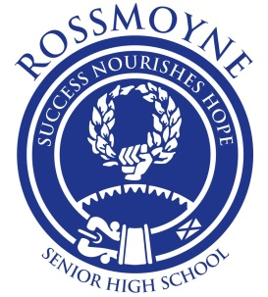

### Semester One Examination, 2015

### Question/Answer Booklet

# MATHEMATICS SPECIALIST

# UNIT 1

## Section One:

## Calculator-free

Your name

Your Teacher’s name

## Time allowed for this section

Reading time before commencing work: five minutes

Working time for this section: fifty minutes

## Materials required/recommended for this section

##### *To be provided by the supervisor*

This Question/Answer Booklet

Formula Sheet

##### *To be provided by the candidate*

Standard items: pens (blue/black preferred), pencils (including coloured), sharpener,

correction fluid/tape, eraser, ruler, highlighters

Special items: nil

## Important note to candidates

No other items may be taken into the examination room. It is **your** responsibility to ensure that you do not have any unauthorised notes or other items of a non-personal nature in the examination room. If you have any unauthorised material with you, hand it to the supervisor **before** reading any further.

## Structure of this paper

|  |  |  |  |  |  |
| --- | --- | --- | --- | --- | --- |
| Section | Number of questions available | Number of questions to be answered | Working time (minutes) | Marks available | Percentage of exam |
| Section One:  Calculator-free | 7 | 7 | 50 | 52 | 35 |
| Section Two:  Calculator-assumed | 13 | 13 | 100 | 98 | 65 |
|  | | | **Total** | 150 | 100 |

## Instructions to candidates

1. The rules for the conduct of Western Australian external examinations are detailed in the *Year 12 Information Handbook 2015*. Sitting this examination implies that you agree to abide by these rules.
2. Write your answers in this Question/Answer Booklet.
3. You must be careful to confine your response to the specific question asked and to follow any instructions that are specified to a particular question.
4. Spare pages are included at the end of this booklet. They can be used for planning your responses and/or as additional space if required to continue an answer.

* Planning: If you use the spare pages for planning, indicate this clearly at the top of the page.
* Continuing an answer: If you need to use the space to continue an answer, indicate in the original answer space where the answer is continued, i.e. give the page number. Fill in the number of the question that you are continuing to answer at the top of the page.

1. **Show all your working clearly**. Your working should be in sufficient detail to allow your answers to be checked readily and for marks to be awarded for reasoning. Incorrect answers given without supporting reasoning cannot be allocated any marks. For any question or part question worth more than two marks, valid working or justification is required to receive full marks. If you repeat any question, ensure that you cancel the answer you do not wish to have marked.
2. It is recommended that you **do not use pencil**, except in diagrams.
3. The Formula Sheet is **not** to be handed in with your Question/Answer Booklet.

Section One: Calculator-free (52 Marks)

This section has**seven (****7)** questions. Answer **all** questions. Write your answers in the spaces provided.

Working time for this section is 50 minutes.

Question 1 (8 marks)

(a) Two vectors,  and , are shown on the grid below.

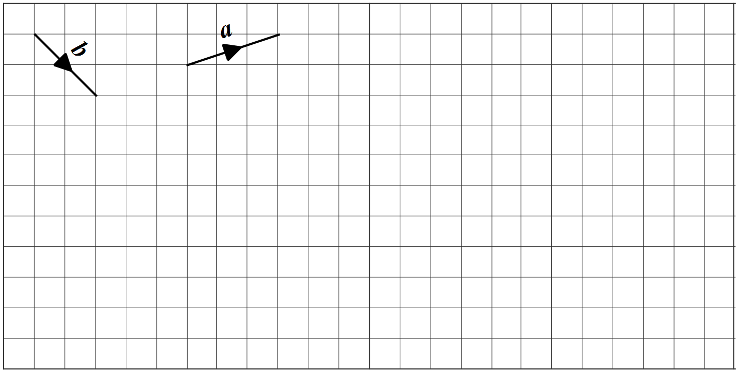

Draw and label the vectors  on the grid, where ,  and . (3 marks)

(b) Determine a unit vector perpendicular to the vector . (2 marks)

(c) The point P divides the line segment from M(-3, 3) to N(13, -9) in the ratio 1:3. Determine the position vector of point P. (3 marks)

Question 2 (6 marks)

The statement 'if two rectangles are congruent then they have the same area' is true.

(a) Write the inverse of the statement and explain whether or not the inverse is also true.

(2 marks)

(b) Write the contrapositive of the statement and explain whether or not the contrapositive is also true. (2 marks)

(c) Write the converse of the statement and explain whether or not the converse is also true. (2 marks)

Question 3 (7 marks)

(a) In the diagram below,  and .

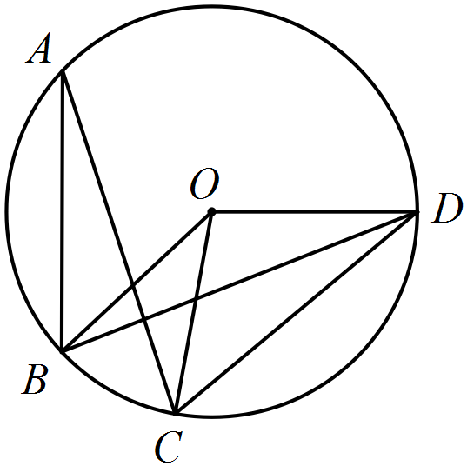

Determine the sizes of

(i) . (1 mark)

(ii) . (1 mark)

(iii) . (1 mark)

(b) Determine, with reasons, the sizes of the angles marked  and  in the diagram below.

(4 marks)

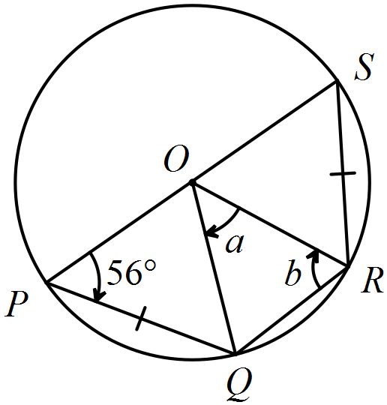

Question 4 (8 marks)

(a) Simplify . (2 marks)

(b) Prove that . (3 marks)

(c) If  and , determine

Hint-use the result from (b)

(i) . (1 mark)

(ii) . (2 marks)

Question 5 (8 marks)

The vectors  are given by  and .

(a) Determine

(i) . (1 mark)

(ii) . (1 mark)

(iii) the **vector** projection of  onto . (2 marks)

(b) Determine the vectors  if  and . (4 marks)

Question 6 (7 marks)

(a) Prove that it is possible to draw a circle through the points , , and  shown below. (3 marks)

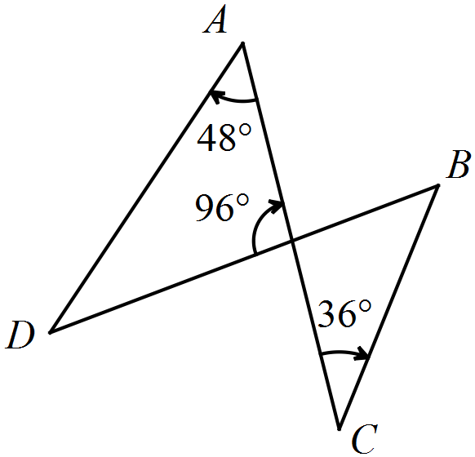

(b) Prove by contradiction that it is impossible to draw a circle through the vertices of the quadrilateral shown below. (4 marks)

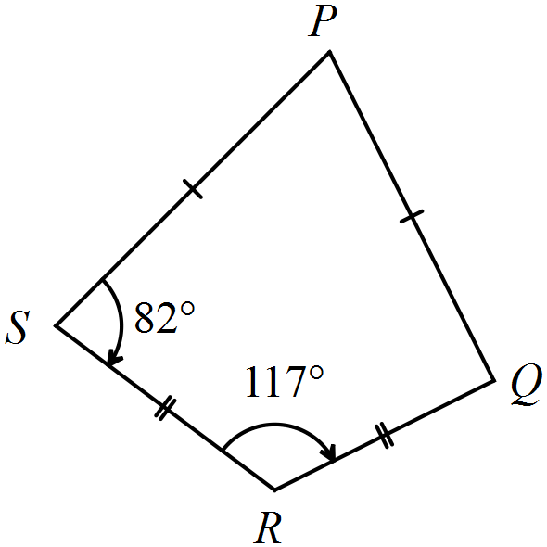

**Question 7 (8 marks)**

A quiz team consisting of 4 people is to be selected from a group of 6 men and 3 women.

(a) How many different teams can be formed? (3 marks)

(b) If there are no women selected, how many teams are possible? (2 marks)

(c) The rules of the competition state that the team must consist of equal numbers of men and women. How many teams satisfy this requirement? (3 marks)

Additional working space

Question number: _________

This examination paper may be freely copied, or communicated on an intranet, for non-commercial purposes within educational institutes that have purchased the paper from WA Examination Papers provided that WA Examination Papers is acknowledged as the copyright owner. Teachers within Rossmoyne Senior High School may change the paper provided that WA Examination Paper's moral rights are not infringed.

Copying or communication for any other purposes can only be done within the terms of the Copyright Act or with prior written permission of WA Examination papers.

*Published by WA Examination Papers*

*PO Box 445 Claremont WA 6910*